Dear Parents and Carers, 4th February 2022
Welcome to our newsletter for this week and welcome to February!
Just a short message from me today where I am going to share with you the learning for next week and on Monday there will be a longer letter from me to bring you up to speed with all of the developments in the school for this term so far, including an introduction to the new Headteacher, Mr Simon Trahern.
Next week’s learning from our Reception Team
In Gruffalo and Elmer classes the children will continue the topic ‘Once Upon a Story’, which is our current topic this term. In English, they will be continuing to look at ‘ You Choose Fairytales’. The children will be helping to finish a story that they will receive from one of the fairytale characters.
We have finished teaching all of the set one sounds in phonics and before we move onto set two we will be focusing on applying these knowledge sounds to read short captions and write short captions. Keep a look out for their Phonics Home Learning book which will come home on Thursday (Elmer) and Friday (Gruffalo) for them to practice these letters. Please make sure this book comes back to school every Wednesday so we can stick the next set of letters in.
In Math’s we will be comparing numbers to 10 using the language ‘greater than’, ‘less than’ and ‘the same as/ equal to’. As the children’s sense of number develops so does their knowledge of where each number sits in relation to other numbers. The children will compare amounts in two or three. To support this concept we will be holding daily votes in class to pick the story for snack time. The children will vote for which book they would like to be read and will compare the votes and to work out the winning title.
Last week in DT, we drew our design for a boat that will help the gingerbread man cross the river. In Science this week, the children will be exploring floating and sinking and comparing different materials to find the best one for our boat.
Next week in Year 1
In English we be thinking of and writing questions about the artist Piet Mondrian. We are going to be creating information sheets about Mondrian to inform others.
In phonics, we have regrouped the children and are excited to begin to use the new RWI reading books at school. We will soon be ready to start sending the book bag books home. More details will follow.
In Maths we will be focusing on numbers to 50. We will compare groups of objects and then numbers to 50 and we will order numbers to 50. We will use the vocabulary greater than, less than and equal to as well as the symbols > < and =
In RE we will be thinking about and trying to answer the question, ‘What is best about God’s Creation?’
In RSHE we will be discussing the question, ‘Why do we need rules in the classroom and in school?’
In Science we will be exploring what it feels like not to have the sense of sight.
In Art we will be completing our final piece of artwork in the style of Mondrian and then we will evaluate our work.
In Geography the children will be looking at a map of the local area and locating where they live on it.
A busy week ahead in Year 2
English: We will begin our week with an exciting start to our new book Tell me a Dragon. We will be immersing ourselves into the imaginary world of dragons.
Maths:
We continue with fractions where we will be looking at finding halves, quarters and thirds of shapes and amounts. We will also be learning to count out loud in fractions eg 1, 1 1/4. 1 1/2. 1 ¾…
Art
Through our learning about Georgia O’Keeffe we will be exploring the concept contrasting/ complementary colour and how she made use of it in her flower and landscape art.
RE
Having looked at Ramadan and the compassionate reasons for this special time of fasting and prayer, we will be exploring the question How do Muslims celebrate Eid-ul-Fitr?. We will also look at why it is important to understand the Faiths, beliefs and viewpoints as part of our British Value system.

Next week’s learning from Year 3
Year 3: In maths we will be continuing to learn about money, adding and giving change.
In English we are starting to write our own informative story of the water cycle.
In Science we are dissecting and looking closely at plants.
Art is creating a large scale landscape piece.
In Geography we will learn about the individual parts of the water cycle.

There is lots going on in Year 4 next week.
We are so excited about our trip to Drusillas Park on Friday next week (11th Feb)! We will leave school at 9.15am so please ensure your child arrives at school promptly for registration at 8.50am. The coach will return to school in time for normal pick up. Your child needs to wear school uniform, a suitable warm coat and footwear. All children will need to have a packed lunch, drink and snack. Please ensure they do not have fizzy drinks or glass bottles.
Now onto our learning for next week...
In Maths, we will be beginning our work on fractions. We will be learning about unit and non-unit fractions and how to represent these.
In Guided Reading, we will be studying an extract from a book called 'The Queen's Nose'.
In Geography, we will be learning about the different layers of a rainforest.
In Art, we will be planning our own piece of artwork inspired by Henri Rousseau.

Next week in Year 5
English
This week we will be immersed in our class story: ‘Cosmic’ by Frank Cottrell-Boyce. The children will be discussing narrative structure (how a story plot progresses), character development and ‘what is a fiction writing style?’.
The children will be planning and drafting their own continuation of the story!
Maths
This week we will be building on our knowledge of fractions. We will be calculating unit, and non-unit, fractions of amounts.
Science
Science this week focuses on the subject of ‘Day and Night’. We will be discovering why the sun appears to rise and set each day when it is, in fact, the Earth that is moving, not the sun. How does that happen?!
RE
We will be continuing to learn about aspects of Islam but we will also be discussing and planning the church service at the end of this half term as it is Year 5’s turn to present the service. Our theme will be ‘God’s Love’.
History
This week we will be researching how the railways came to Sussex and what were the effects of enabling so many people to travel easily. Something we take for granted today was exciting and new to the residents of Sussex less than 200 years ago!
PE
We will be reviewing our hockey matches and discussing how tactics are important. We will be refining our wonderful Pink Panther dance routines and giving feedback to each group/dancer.
And finally from Year 6
English: practise SATs reading, spelling, grammar and punctuation papers. We will be continuing to read our new story ‘Between Sea and Sky’ embarking on some work around this.

Maths: practise SATs arithmetic and reasoning papers. Alongside this we will continue to look at shape including perimeter, area and volume.

Geography: we will be exploring the question – how do volcanoes happen? Looking at the locations of volcanoes and volcanic activity.

Science: We will be writing up our conclusions from our science investigations and discussing our findings.

Have a lovely weekend
Joy Waelend
Co-Headteacher

MESSY CHURCH
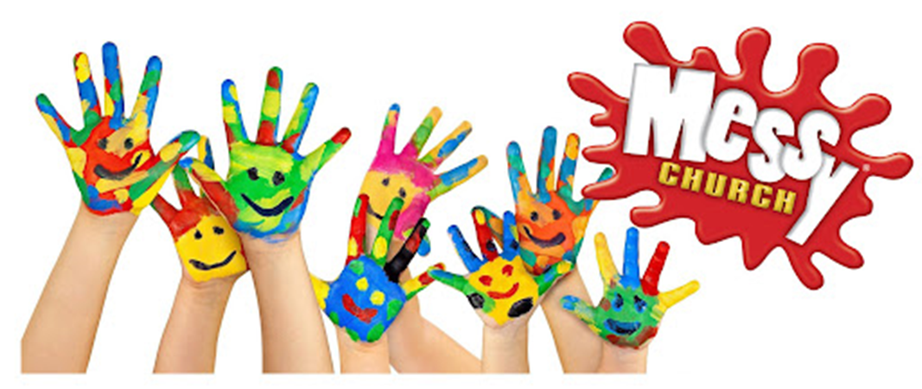
ST BOTOLPH’S CHURCH, LANSDOWNE RD, WORTHING, BN11 4LY

COME AND JOIN US FOR FUN, CRAFTS, SINGING, GAMES, FOOD AND LOTS MORE!

SHARING GOD’S LOVE
THE FIVE LOAVES AND TWO FISHES!

SUNDAY 27th FEBRUARY
3.00pm to 5.00pm
Contact: Sally at sallypritchard15@gmail.com 07908069819
Peter at peterkane@cantab.net 01903 339656

Messy Vintage and SEND are most welcome to join in.
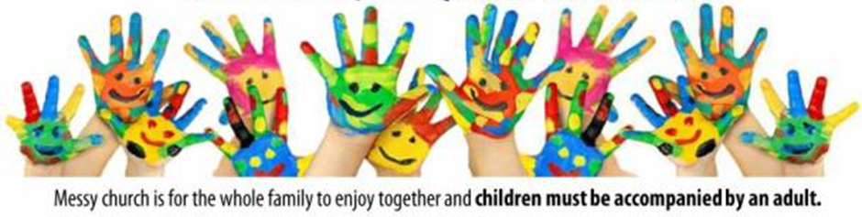

Holiday Lunches
For anyone who needs a bit of support with food for the family, we are inviting you to join us for a meal together.

We are delighted to be able to offer a meal together in a friendly and communal way. We invite you to arrive around 12noon ready for lunch at 12:15pm. We will eat around tables, with a manageable level of friendly chaos! There will be an optional craft activity to take home with you as well. A takeaway option is available.

