Dear Parents and Carers, 11th March 2022
It has been a real pleasure to see so many of you at our second Parents and Carers Evenings of the year, during this past week. It was delightful to be able to meet most of you at the door, either on the way in or after the meetings with the teachers and to hear the news of what the teachers have had to say to you. Thank you to you all for being so positive about the changes you are seeing at Heene and how, as a result of these, your children are beginning to thrive. There is still so much to do, but week by week we are seeing important green shoots upon which Mr Trahern will be able to build when he begins his role as Headteacher at Heene in September. Thank you again to the Friends of Heene for providing tea and coffee for you to enjoy and we look forward to seeing you at some planned ‘Friends’ events in the coming weeks.
It has been a busy couple of weeks at Heene. This morning we had the pleasure of welcoming the Safeguarding in Education Team from WSCC into school to look at the continued improvements we are making to our Safeguarding procedures and practices in school and in the learning the children are undertaking. This was a positive visit and one which showed how far we have come since their first visit last year in May.
Today, we also had teachers taking part in Lead Teacher training to support the work we are doing in our new Read, Write, Inc. scheme. As you are aware this is the new Phonics Scheme which we are now using to great effect in Years R and 1 currently. The progress the children have made has been wonderful where we have seen many children making great leaps in their ability to read, understand and enjoy what they are reading. The whole school training for all of the staff will take place on Friday 29th April, which will be our INSET Day, and the school will be closed to children.
It was also fabulous yesterday to welcome Clive Latter (From St Matthew’s Church) back to Heene to take our Face to Face Collective Worship once more. We are so grateful for the weekly Collective Worship Videos he has provided for us but it was lovely to be able to worship together once more in person. Thank you Clive.
One reminder please: May I remind parents not to bring their dogs onto the school playground when dropping off your children or collecting them at the end of the day. This includes puppies who might be carried. On the occasions when we have dogs in school, it is for a clear purpose and we have a specific risk assessment in place for this. Other than these specific circumstances we do not allow any dogs onto the school site. Thank you for your co-operation with this.

Our awards this week: I hope you will agree that there has never been a better time to present a KINDNESS award. Sometimes the events around us can be difficult to understand and at times it feels that there is little we can do. However, our emphasis this week has been on looking for genuine kindness around our school and the following children have been awarded a Headteachers Award for Kindness, which as you know is part of our ‘Heene Way’. This week we have also included the reasons why the teachers have given the awards, so that you too can celebrate their achievements with us.
Pupil of the Week – Our KINDNESS Award

Early Years Theerdha from Elmer and Marsel from Gruffalo
Year 1 Lucas and Bonnie from Funnybones and Michael from Paddington
Year 2 Razvan and Matylda from Gravett and Juno and Valentina from Jeffers
Year 3 Harry and Lucia from Pichon and Flynn and Autumn from Stanton
Year 4 Leo and Maja from Hardy and Grace and Alice from Rundell
Year 5 Rory, Freya, Wolfie & Yoana from Morpurgo and Felix and Molly from Blackman
Year 6 Lilly from Horowitz and Arthur from Almond

A Netball Success to Report
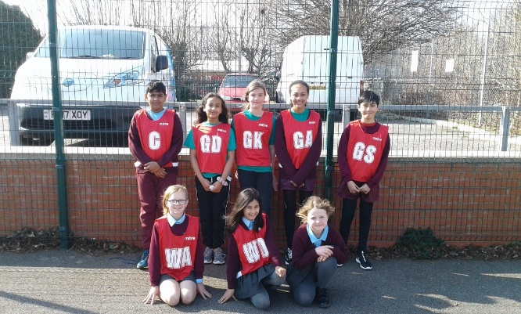
It was an absolute pleasure to accompany the Year 5 and 6 netballers who competed in freezing conditions on Monday afternoon in the Worthing Schools Netball Festival. The team showed excellent resilience and perseverance to draw 3 out of their 7 games, a real improvement from their first tournament at the beginning of the year. A massive thank you also goes to the parents who supported us outside on this bitter afternoon – we are all very proud of the children’s performance and their determination. A true representation of our Heene school values from everyone Thank you from Miss Moyle!

RED NOSE DAY – NEXT FRIDAY:
Next Friday, March 18th is Red Nose Day where we collectively have the potential to make a real difference to the lives of others, even at a time when things are so challenging for us all. So next Friday we are inviting the children to come to school dressed in red (a little, or a lot!) and to being in a contribution of £1 which will go to Comic Relief. We look forward to Heene being a sea of shades of red in support of others. Thank you so much for your support of this fabulous charity.
Wishing you all a lovely weekend
Miss Joy Waelend and Mrs Julia Sherlock

