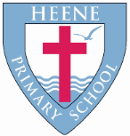
Heene Church of England (Aided) Primary School
‘Learning together, loving others, guided by God’

Heene Curriculum Spring 2022

Year Group | Key Texts | RE | Science | History | Geography | Computing | Art | DT | PE | RSHE | Music | French
EYFS  Once upon a story  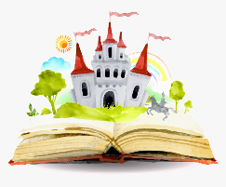 | The Three Billy Goats Gruff  The Gingerbread Man  You Choose Fairytales | Stories of Faith  Noah’s Ark  Salvation  Why do Christians put a cross in an Easter garden? | Floating and Sinking  Healthy Bodies | Once upon a Story  Understanding the past through settings, characters and events. | - Environments – natural and made by people.  - Compare and contrast environments.  - Seasons | Coding caterpillars  Logging in using username and password | Can you make a picture of what you See?  Observational art  Learn simple weaving techniques | Mechanisms and structures  Design and make a boat to cross the river safely. | Dance – creating and performing a dance to Goldilocks and the three bears | Building relationships  Self-regulation | EVERYONE!  (Charanga)  Explore: family, friends, people and music from around the world
Year 1  What is courage?  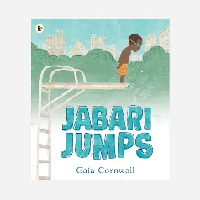 | The Dot  Jabari Jumps  Ada Twist Scientist | Creation  Who Made the World?  Salvation  Why does Easter matter to Christians? 1 | What makes us human?  Parts of the body  Our senses  Materials – What could this be used for?  Exploring objects and the materials they are made from | Can people change the world?  Florence Nightingale  Mary Seacole | Where do I live?  - Countries and capital cities of the UK  - Different settlements  - Our local area  - My address | How can you change the writing on a computer?  Font  Size  Colour  Space bar  New line  Redo and undo | Are all colours a Mixture of Other Colours?  Artist study: Piet Mondrian | Textiles  Design and make a puppet to re-tell a story. | Gymnastics – rocking and rolling  Fitness 15  Effects of fitness on the body.  Partner ganes  Throw, catch and aim | How do I stay safe online?  Why do we need rules?  How have I changed since I was a baby? | IN THE GROOVE (Charanga) Blues, Latin, Baroque and Bhangra.  ROUND & ROUND  Bossa Nova
Year 2  Ice or Flames?  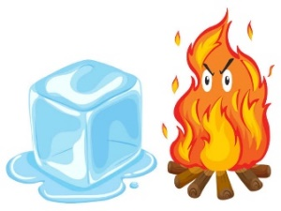 | Tell me a dragon  Dragon Post  The Ice Bear  (Author comparison Jackie Morris) | Islam  How do some  Muslims show Allah is compassionate and merciful?  Salvation  Why does Easter matter to Christians? | Plants  How do plants grow? | Could the Great Fire of London have happened today? | Where in the world am I?  - Continents  - Poles  - Oceans  - Continent study | We are Researchers (using Google slides) | Artist Study: Georgia O'keeffe. Complementary colours. | Mechanisms and structures  Design and make a vehicle with moves using wheels and axles. | Group Games  Gymnastics  Dance  Racket Skills | Relationships  Rights being treated with care and compassion. Right and wrong Effects choices can have on others.  British Values. | I WANNA PLAY IN A BAND  Rock. Playing in an ensemble  ALL ABOARD!  (Link to Topic)
Year 3  The Ancient World  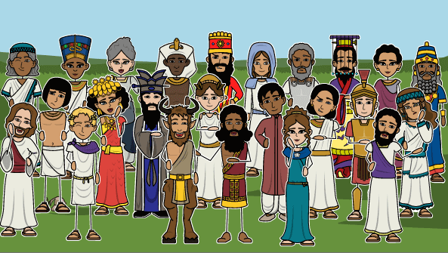 | Once upon a raindrop  Rhythm of the rain | Islam  How do Muslims show their submission and obedience to Allah?  Salvation  Why do Christians call the day Jesus died Good Friday? | Plants  Rocks and Solids | Ancient Civilisations  What did the Ancient Civilisations have in common? | Rivers – Where do Rivers lead?  - Water Cycle.  - River features.  - Uses of rivers.  - River pollution and its effects.  - Local rivers  - River investigation. | Word processing Presentation skills – Powerpoint – Font, colour, size, picture | Are all Landscape Pictures Similar in Style?  Artist study: John Constable | Mechanics and structures unit  Packaging for a food product to keep it protected. | Net, court and wall games  Dance  Gymnastics  OAA | Online safety.  Privacy.  Sleep patterns.  Self-esteem | THREE LITTLE BIRDS  Reggae; Singing and performing  BRINGING US TOGETHER  Disco/  singing techniques | Niveau Bleu  Module 3  Numbers 7-10  Paris Landmarks  Module 4  Numbers 11-12  There is/are  Paris Landmarks
Year 4  Settle or Invade?  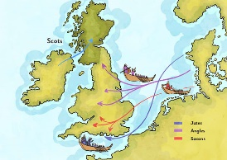 | The Explorer  The Great Kapok Tree  Wild Animals of the South | Islam  Why do Muslims call Muhammad the ‘seal of the prophets  Salvation  What is the significance of the stations of the cross? | States of Matter Inc. Water Cycle – review from Year 3 Geography | Anglo Saxons  What’s the difference between an Invader and a Settler? | Why do rainforests matter?  - Map work – where are the rainforests?  - Four main layers of vegetation.  - Climate and biomes.  - Indigenous rainforest tribes.  - Deforestation. | Word processing Presentation skills – Powerpoint - hyperlink, transition, audio, video | Jungle Landscapes  Artist study: Henri Rousseau | Cooking and nutrition  Baking scones to provide scones to an audience. | Fitness  Indoor Athletics  OAA  Gymnastics | Privacy online.  Special memories  Change/loss and associated feelings. | GLOCKENSPIELS 1 | Niveau Blanc  Module 3  Les animaux  Couleurs  Module 4  Dans la mer  Dans les bois
Year 5  Exploration and opportunity  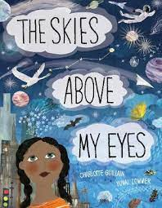 | Cosmic  Mars Curiosity Rover  The skies above my eyes | Islam  What does the Qu’ran reveal about Allah and how is it a guide for living?  Salvation  What did Jesus do to save human beings? | Earth and Space | A local history study post 1066  How did the railways ‘build’ Sussex? | Can a coastline disappear?  - Effect of erosion– caves, stumps and stacks.  - Coastal defences.  - Impact of the sea on human activity.  - Effect of climate change on the coastline and coastal towns and villages. | Word processing Presentation skills – Powerpoint – non-linear, navigate | Seascapes  Do Seascape Artists use the same techniques as Landscape Artists?  Monet, Turner, Winslow homer | Cooking and nutrition  Making pizza to provide for others at a planned event | Hockey (invasion games)  Dance  (story-telling and expression) | Feelings  Relationships | GLOKENSPIELS 2 | Niveau Rouge  Module 3  Ordinal numbers  Capitals around the world  Module 4  Writing a letter
Year 6  Wonders of the Universe  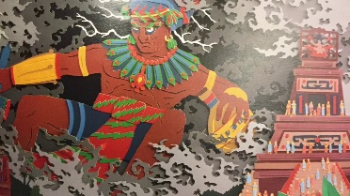 | Between sea and sky  Rain Player  Earth shattering events | Islam  How does tawhid  create a sense of  belonging ?  Salvation  What difference does the resurrection make to Christians? | Animals Inc. Humans  Living things and their habitats | Mayans  What did the Mayans know? | Does the Earth open up?  - Layers of the Earth.  - Plate tectonics.  - Ring of Fire.  - How countries predict, prevent and prepare for earthquakes and volcanoes.  - Maps to locate volcanoes of the world using 6 figure grid references. | Word processing Presentation skills – Powerpoint – Slide transition animation, copyright, peer assessment | World Art-  Art from different countries and cultures  Artist study: Magdalene Odundo  Clay sculptures  Design and create a sculpture | Textiles  Design and make a bag for a specified person and purpose. | Orienteering  Indoor Athletics  Fitness  Gymnastics | Relationships  Appropriate physical contact/touch and communication  Changes – mood swings and physical changes (coping strategies) | RECORDERS 2 | Niveau Tricolore  Module 3  My day at school  Module 4  Getting to school  Recreation

