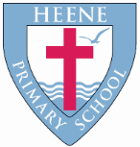
Heene Church of England (Aided) Primary School
‘Learning together, loving others, guided by God’

Year 5 Autumn 2022

TOPIC | All Change!
WOW STARTER | A Viking Feast! | Enrichment - Planned Trips or Visits | TBC

Subject | Key Question | Focus
Geography | Mountain Environments – what and where? | What are mountains and how are they formed?  Where are the World’s mountains and mountain ranges?  What lives and grows in a mountain habitat?  What threatens a mountain environment?  What are the features of mountains?
History | What did the Vikings do for Britain? | Where did the Vikings sit in British History?  Where did they come from and why did they come here?  Who were the Vikings and when did they invade?  What was Viking society like?  What were they good at?  Why did they get a bad reputation?  When did they leave and what was their legacy?
Quality Texts as an English focus | 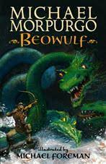  Beowulf  By Michael Morpurgo  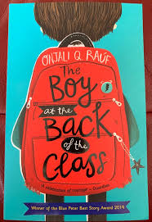  The Boy at the Back of the Class  By Onjali Rauf  Range of Fiction, Non-fiction and Poetry topic-linked texts.
English Focus | Character descriptions (Grendel)  Diary writing  Poetry (linked to refugees)  Narrative writing to retell, entertain, move.  Non-chronological report
Maths Focus | Number and Place Value with Reasoning, Addition and Subtraction (inc. money), Perimeter, Statistics, Multiplication and Division, Area
RE | Creation  How do Christians interpret the Creation story?  Creation and Science: conflicting and complimentary? | Outline the importance of Creation on the timeline of the ‘big story’ of the Bible.  Identify what type of text some Christians say Genesis 1 is, and its purpose.  Suggest what Genesis 1 might mean, compare ideas in which Christians interpret it, show awareness of different interpretations.  Show an understanding of why many Christians find Science and faith go together.
 | Incarnation  Was Jesus the Messiah? | Jesus was Jewish.  Christians believe Jesus is God in the flesh.  They believe Jesus’s birth, life, death and resurrection were part of a longer plan by God to restore the relationships between humans and God.  The Old Testament;  Jesus the Messiah;  Christians see Jesus as their saviour.
Science | Can the properties of all materials change? | How to group materials based on their properties using more complex vocabulary.  What is dissolving? What is melting?
 | What if forces did not exist? | What are forces?  What is gravity and air resistance?  What is water resistance?
Art | Telling a story… | Theme: Tapestry  Artist Focus: Various famous tapestries  Outcome: Design own embroidery that tells a story.  Use a cardboard loom to weave a simple tapestry.  Know the history of tapestries and embroideries and the artists and crafts people who created them.  Link to History: Telling stories from the past
DT | Design and make a pencil case  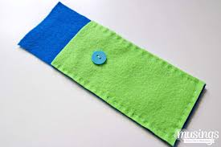 | Textiles (felt)  Purpose: Design and make an object for a particular purpose.  Focus:  Decide on pattern layout and cut using a range of fabrics.  Demonstrate an awareness of seam allowance.  Join buttons and loops using over sewing and back stitch.  Select the needle to match the thread.  Add applique decorations, beads and sequins using over sewing and back stitch.
Music | Pulse & Rhythm  Rhythm boxes and composing patterns  Boomwhackers –pitch and pentatonic scales – compose and perform
PE | Swimming (Autumn 1 & 2: 10 weeks)  Football  Gymnastics
Computing | E-Safety  What is copyright and the law around social media?  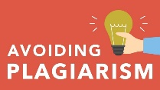 | Know what plagiarism is.  Know what copyright restrictions are.  Know the age restrictions for social media websites such as Facebook, Twitter and Instagram.  Know how to use WhatsApp and other chat APPs responsibly.  Understand that from the age of 10 I can be arrested and perhaps charged for sending explicit images and messages to other people.
 | Creating media – Introduction to vector graphics | In this unit, learners start to create vector drawings (using Google Drawings). They learn how to use different drawing tools to help them create images. Learners recognise that images in vector drawings are created using shapes and lines, and each individual element in the drawing is called an object. Learners layer their objects and begin grouping and duplicating them to support the creation of more complex pieces of work.
RSHE | E-safety  Relationships  Health | Positive relationships in person and online  Healthy lifestyles and balanced lifestyles
French | A number of different activities to learn how to say the date in French. | The vocabulary for the days of the week, the months, numbers 1-31, the structures involved for asking and saying the date and how to ask and say when your birthday is.

