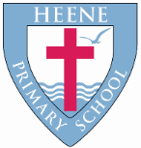
Heene Church of England (Aided) Primary School
‘Learning together, loving others, guided by God’

Year 3 Autumn 2022
TOPIC | Our Ancient Ancestors
WOW STARTER | Cave Art | Enrichment - Planned Trips or Visits | Butser Farm  History artefacts

Subject | Key Question | Focus
Geography | Is Worthing a good settlement? | Be able to locate the South East of England on a map of the UK.  Explain how land is used in the local area.  Compare land use on the South Downs with land use on Worthing seafront and identify how and why they are used for different purposes (agriculture and tourism).  We will observe and identify human and physical features around Worthing.
History | What was life like for our Ancient Ancestors? | Describe what life was like during the three stages of the Stone Age.  Explain how Britain changed during the Stone Age using a timeline.  Understand the meaning behind the words, Palaeolithic, Mesolithic and Neolithic.
Quality Texts as an English focus | 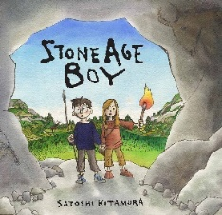  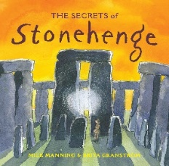  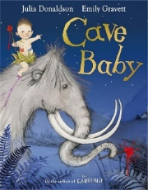  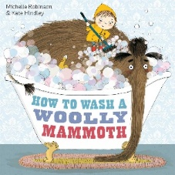  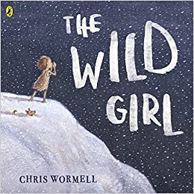  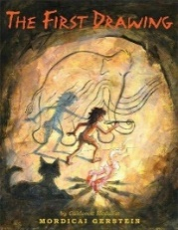
English Focus | Descriptive writing about a cave.  Diary entry about The Wild Girl.  Poetry inspired by Cave Baby.  Narrative inspired by Stone Age Boy.  Instruction writing based on How To Wash A Woolly Mammoth.  Non – chronological writing about Stonehenge.
Maths Focus | Place value – 3 digit numbers, understanding ones, tens and hundreds, partitioning.  Addition and subtraction – within numbers to 1000.  Multiplication and division – Knowledge of tables 3 x, 4 x and 8 x.
RE | What do Christians learn from the creation story? | Be able to place the concepts of God and Creation on a timeline of the Bible’s Big Story.  Make clear links between Genesis 1 and what Christians believe about God and Creation.  Describe what Christians do because they believe that God is creator (for example follow God, wonder at how amazing God’s creation is, care for the earth in specific ways).  Ask questions and suggest answers about what might be important in the creation story for Christians living today and for people who are not Christians.
 | Incarnation – God – What is the trinity? | Identify the difference between a ‘Gospel’, which tells the story of the life and teaching of Jesus, and a letter.  Offer suggestions about what texts about baptism and Trinity might mean.  Give examples of what these texts mean to some Christians today  Describe how Christians show their beliefs about God the Trinity in worship (in baptism and prayer, for example) and in the way they live.  Make links between some Bible texts studied and the idea of God in Christianity, expressing clearly some ideas of their own about what the God of Christianity is like.
Science | What do forces do? | What are forces?  How do different surfaces affect the motion of an object?  How do magnets work?  Which materials are magnetic?  How do magnetic poles work?
Art | Does a picture have to look like something real? | Theme: Abstract art  Artist Focus: Pollock, Miro, Riley  Outcome: own abstract artwork  Link to History: Cave art - Abstract expressionism
DT |  | Food technology  Can I design a biscuit for a purpose?  Christmas themed.
Music | Theme 1: Let Your Spirit Fly.  Theme 2: Glockenspiels.
 | We will be performing to other year groups.
PE | Invasion Games  Gymnastics  Multi skills  Skipping and fitness
Computing | What can I do to keep me safe online?  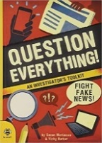 | E-Safety  - I know the information that I need to keep private in real life and on computers.  - I know what makes a strong password.  - I know what a phishing e-mail is and how it tries to get my details.  - I know what privacy settings are and how to set them.  - I know how to find out if what I read is truthful or not (book link)
 | What is a blog? | Internet Skills  - I know what a blog is.  - I can write my own blog and save it onto my Google Classroom account.  - I understand that a blog is written for an audience and needs to keep them interested.  - I know why people write blogs.  - I am starting to understand how to keep safe while writing a blog.
RSHE | Keeping safe and handling emotions | - The difference between good and bad secrets, and the importance of sharing bad secrets  - How to keep safe in an emergency  - How to describe and manage feelings
French | - Greetings  - Paris landmarks  - Numbers  - Countries of the UK

