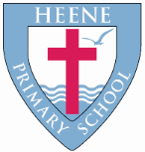
Heene Church of England (Aided) Primary School
‘Learning together, loving others, guided by God’

Year 2 Autumn 2022

TOPIC  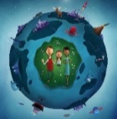 | Here we Are
WOW STARTER | Here We Are – Oliver Jeffers | Enrichment - Planned Trips or Visits | Beach / Park visit

Subject | Key Question | Focus
Geography | What would you find on a West Sussex journey?  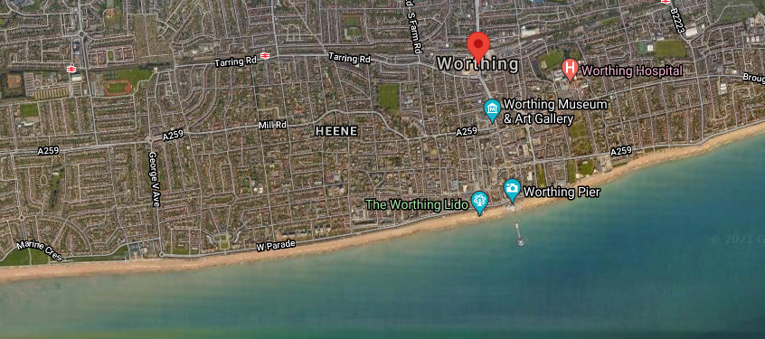 | What I will know by the end of the unit  - Know what the United Kingdom is and where Worthing is in relation to London  - Be able to find and locate West Sussex on a variety of local, national and global maps  - Identify the key human and physical features of West Sussex  - Compare these features with Heene and the local area  - How West Sussex has changed during time  - Use digital maps to compare human and physical features of West Sussex now and in the past
History | How has our town changed?  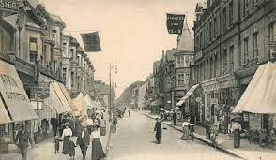 | What I will know by the end of the unit (Historical skills and enquiry)  - Our local area has changed over time  - That people have been in our area for a very long time and that has caused change  - Know what these changes look like on a timeline  - How to sequence and compare pictures and artefacts on a Worthing timeline  - Describe memories that people have of Worthing in the past  - Use digital maps to find out what has changed in Worthing in the last 100 years
Quality Texts as an English focus | 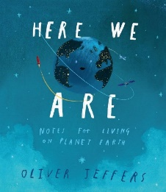  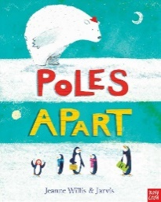  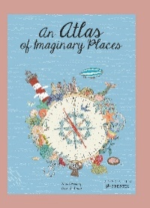
English Focus | Non fiction writing – leaflets, information book page about penguins – postcards  GPS – Capital letters, full stops, finger spaces, sentences, adjectives.  Imaginative writing – descriptive sentences, creative description of an imaginary world, poetry.  GPS – expanded noun phrases
Maths Focus | Place value within 20, Addition and subtraction Measurement: money Multiplication and division
RE | Who made the world? | What I will know at the end of this unit  - Retell the story of creation from 1:1-2:3 simply.  - Say what the story tells Christians about God, creation and the world.  - Give at least two examples of what Christians do to look after the world for God.  - Think, talk and ask questions about living in an amazing world.
 | Why does Christmas matter to Christians?  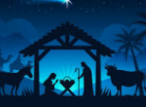 | What I will know at the end of this unit:  - Recognise that Incarnation is part of the ‘Big Story’ of the Bible.  - Tell the story of the birth of Jesus and recognise the link with  Incarnation — Jesus is ‘God on Earth’.  - Think, talk and ask questions about the Christmas story and the lessons they might learn from it.
Science | How do living things survive?  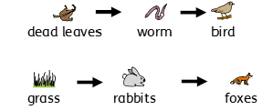 | What I will know at the end of this unit:  - Animals and plants depend on each other to survive.  - All living things (or things that were once living) have a part to play in food chains. Without them, other animals and plants may not be able to survive.
 | 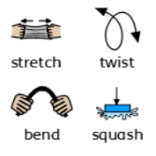  Are all materials useful? | What I will know at the end of this unit:  The shape of some materials can be changed when they are stretched, twisted, bent and squashed.
Art | 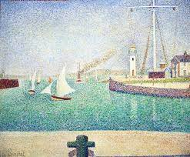  Who was Georges Seurat and what style of art did he create? | Theme: Texture and Tone  Artist Focus: Georges Seurat  Outcome: A painting in the style of George Seurat showing different tones and texture.
DT | How do we design and make a Christmas decoration?  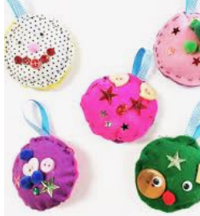 | What I will know at the end of this unit:  - How to draw around a given template.  - How to cut out simple shapes from felt.  - How to join fabrics by using running stitch and over sewing.  - How to thread a needle and be more confident doing this on my own.  - How to decorate using fabric pens.  - How to glue on decorations such as sequins, beads and ribbons.
Music | Listening: Hands, Feet, Heart  Focus: Finding the pulse and identifying instruments.  Activities: Clapping rhythms, singing, playing instruments, composing and improvising.
PE | Multiskills  Ball skills  Gymnastics  Games Making
Computing | Is everything safe on the internet? | What I will know by the end of the unit:  - I know the information that I need to keep private in real life and on computers.  - I know what the SMART rules are.  - I understand there are possible dangers on the computer.  - I know that people are not always who they say they are online.  - I know what a virus is and how one may be sent to my device/computer.  - I know what to do if something upsets me.
 | Digital photography | What I will know by the end of the unit:  I can recognise that different devices can be used to capture photographs and will gain experience capturing, editing, and improving photos. Finally, I will use this knowledge to recognise that images they see may not be real.
RSHE | How can I cope with strong feelings?  What information do you access online? How do you ensure you safely search for information?  What safety choices do we make daily? | Show an understanding of their own feelings and those of others, and begin to regulate their feelings accordingly.  Know that the same principles apply to online relationships as to face-to-face relationships,  Know how to ask for advice or help for themselves or others, and to keep trying until they are heard.

