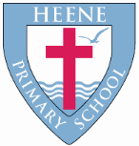
Heene Church of England (Aided) Primary School
‘Learning together, loving others, guided by God’

Year 1 Autumn 2022

TOPIC | The Great Outdoors  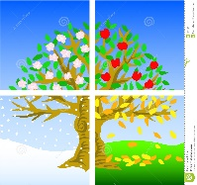
WOW starter | 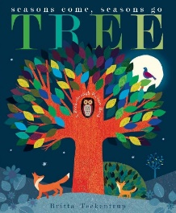  Has anyone lost an owl?  We will find one in our classroom and try to find out more about it… | EXCITING EXPERIENCES (may include) | Printing and Collaging trees throughout the seasons. An Autumn walk. Picking fruit from our trees in the outdoor classroom. A Punch and Judy visitor. A visit from a grandparent. A hedgehog visitor. Create art in the style of Andy Goldsworthy.

Subject | Key Question | Focus
Geography | Is Heene a good place to live? | What I will know by the end of the unit  - How to plan a journey in the school grounds using compass directions  - Be able to follow a journey in the school grounds using the directions  - Create a map with symbols and a simple key of my journey  - Use my journey to describe the physical features of my school  - How to use aerial photographs and digital maps of my local area  - Be able to identify and describe different human and physical features in and around Heene  - Look at the human and physical features of our local area which are special to us e.g. the beach, coast, South Downs
History | How do we live? | By the end of the unit the children will know:  - That people are older and younger than them.  - How things have changed from when their grandparents and parents/carers were younger.  - To know that there was a time before their grandparents were born and seaside holidays have changed over time

Quality Texts as an English focus | 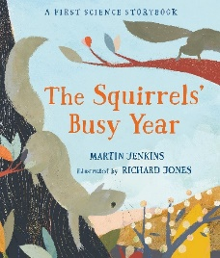  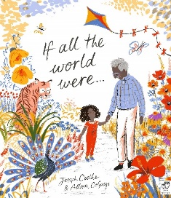

English Focus | 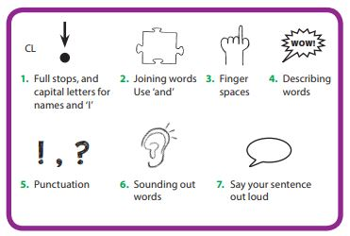  In English we will find out about owls and hedgehogs using what we already know and asking questions to find out new information. We will use a range of sources (books, videos, experiences and visitors) and then write this information as sentence statements, beginning to identify some features of non-fiction (heading, text boxes, photographs and captions). We will write a diary in the first person, as an owl in the text using role play and using our knowledge from Science to add detail to our writing. We will read, join in and perform poetry about animals. We will think about people who are special to us and write more than one sentence to reflect this.
Maths Focus | Number: place value (within 10) looking at sorting/counting/representing objects, counting forwards/backwards, counting one more and one less, comparing numbers and ordering numbers using a number line.  Number: Addition and subtraction (within 10) looking at parts and wholes as a model, addition fact families, finding number bonds to 10, subtraction and comparing addition and subtraction statements.  Geometry: looking at recognising and naming 3-D shapes, sorting 3-D shapes, recognising 2-D shapes and patterns involving 2-D and 3-D shapes.
RE | What do Christians believe God is like? | By the end of the unit the children will be able to:  - Identify what a parable is.  - Tell the story of the Lost Son from the Bible and recognise a link with the concept of God as a forgiving Father.  - Give clear, simple accounts of what the story means to Christians.  - Give at least two examples of a way in which Christians show their belief in God as loving and forgiving; for example, by saying sorry; by seeing God as welcoming them back; by forgiving others.  - Give an example of how Christians put their beliefs into practice in worship; by saying sorry to God, for example. Think, talk and ask questions about whether they can learn anything from the story for themselves, exploring different ideas.
Science | Why does the weather change? | Seasonal changes  We will observe changes across Autumn and Winter.  We will describe the weather and how the day length varies with the season. We will learn the months of the year and talk about when our birthday is.
Art | Can you make art out of nature? | Artist Focus: Andy Goldsworthy  We will explore making art using natural objects such as pine cones, pebbles, shells, acorns, leaves, twigs and seeds. Please collect natural items when you are out on a walk and bring them to school. We plan to take the children to the beach to make beach art.
DT | How do things move?  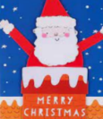 | Mechanisms and structures  The children explore simple levers and sliders and then use these in a Christmas card.
Music | Focus: Hey You! Hip Hop style  Activities:  - Listen and appraise a range of Hip Hop songs to include Me, Myself and I by De La Soul, Fresh Prince of Bel Air by Will Smith and It’s Like That by Run DMC.  - Find the pulse.  - Listen to the rhythm and clap it back.  - Listen and sing back.  - Learn to sing a song
PE | Dance (inside)  The children will listen and respond to a variety of music representing different themes (trees, pirates, weather and toys). They will copy and repeat movements and explore their own movements. They will link movements together to create and perform dances.  Ball skills (outside)  The children will learn to roll and throw a ball accurately. They will learn to catch a ball and then play different games to continue to develop these skills.  Multi-skills (inside)  The children will learn to run effectively, learning to negotiate different obstacles and move in different directions. The children will learn to balance on their own and with a partner and then demonstrate what they have learnt.  Skipping (outside)  The children will learn to skip around the area before learning to skip using a skipping rope. They will learn to skip at different speeds and develop their skills while negotiating the space.
Computing | How can I be safe online? | - Know the information I need to keep private in real life and online.  - What the SMART rules are.  - To log on and off the network.  - To understand how computers and IT devices are used in the world around them.  - To develop their mouse and keyboard skills.  - To use the computer to create their own pictures based on artists.
RSHE | Being me in my world | Children will learn:  I can explain why my class is a happy and safe place to learn.  I can give different examples where I or others make my class happy and safe. This will include thinking about who is special to me, how people care about one another, identifying my feelings and how different things can have an impact upon this. I will talk about how it feels to achieve and how it feels if I make a wrong choice. This will include learning about the Heene Way and what this looks like at Heene.

