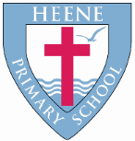
Heene Church of England (Aided) Primary School
‘Learning together, loving others, guided by God’

Year 4 Autumn 2022

TOPIC  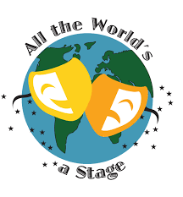 | All the World’s A Stage
WOW STARTER | Roman workshop at Worthing Museum | Enrichment - Planned Trips or Visits | Fishbourne Roman Palace

Subject | Key Question | Focus
Geography | Why are there lines around the world? | Northern and Southern Hemisphere, the Tropics of Cancer and Capricorn and the Arctic and Antarctic Circle.  Latitude and longitude.  World time zones.  North and South America.
History | Were the Romans really rotten? 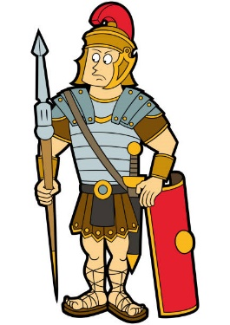 | The Roman Empire and its impact on Britain.  Why the Romans invaded Britain.  What life was like for all groups of people in Roman Britain.  Timelines to explain how Britain changed during Roman Britain.  How the Romans used technology to become so powerful  What the Romans brought to Britain and the legacy they left behind.  Queen Boudicca and her revolt against Roman rule.  The emperors and leaders who had the greatest impact on the Romans in Britain.
Quality Texts as an English focus | 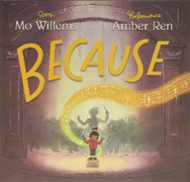  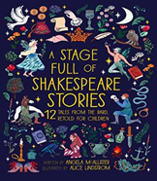  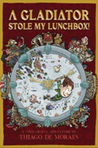
English Focus  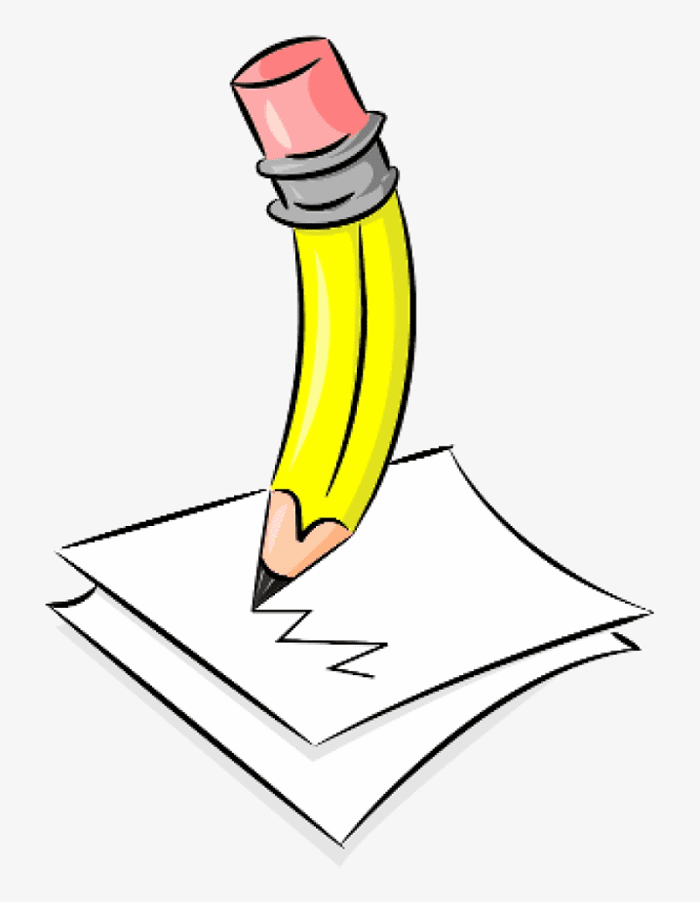 | Descriptive writing  Informal letter  Narrative – story opening  Discussion text (balanced argument)  Poetry (rhyming couplets)  Non-Chronological report  Grammar, punctuation and spelling focus: Word endings e.g. /ure/ (treasure, measure), prefixes e.g. ‘in-’, ‘il-’, ‘im-’ and ‘ir-‘, adding suffixes beginning with vowel letters to words of more than one syllable e.g. ‘-ing’, ‘-en’, ‘-er’, ‘ed’, homophones e.g. peace/piece, main/mane, fair/fare, possessive apostrophe with singular proper nouns e.g. Cyprus’s population.
Maths Focus  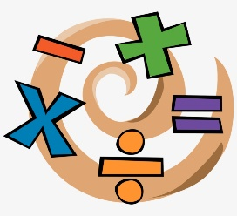 | Place value: Numbers to 1,000, numbers beyond 10,000, Roman numerals, rounding to the nearest 10, 100 and 1,000.  Addition and subtraction: adding and subtracting 3 and 4 digit numbers  Area: calculating the area of shape by counting squares, creating shapes based on area.  Multiplication and division: Multiply and divide by 3, 6, 9, 7, 10, 11, 12 and 100
RE | What do Adam and Eve’s actions teach us?  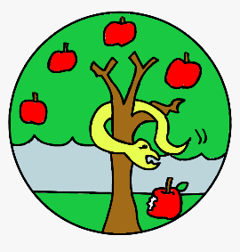 | The story of Adam and Eve and what it teaches Christians.  How the Bible shows that God wants to help people to be close to him.  How and why Christians might pray to God, say sorry, forgive and ask for forgiveness.  How God keeps his relationship with humans and gives them guidelines on how to live (Ten Commandments).  Links between what stories in the Bible say about human beings, and pupils’ own ideas about how people should behave.
 | Do you believe God came to Earth at Christmas?  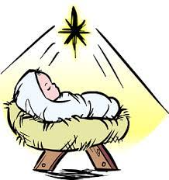 | John 1 as part of a ‘Gospel’, noting some differences between John and the other Gospels.  Offer suggestions for what texts about God might mean.  Give examples of what the texts studied mean to some Christians.  Describe how Christians show their beliefs about God the Trinity in the way they live.  Make links between some of the texts and teachings about God in the Bible and what people believe about God in the world today, expressing some ideas of their own clearly.
Science | What are the different ways living things can be classified?  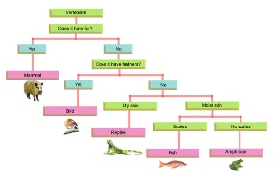 | Strand of Science:  Living things and their habitat.  -How living things can be grouped.  - Classification keys.  - How environments change.
 | Where does our food go?  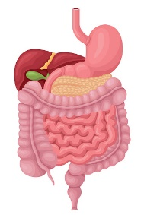 | Strand of Science: Animals Inc. Humans  - Describe the simple functions of the basic parts of the digestive system in humans  - Identify the different types of teeth in humans and their simple functions  - Construct and interpret a variety of food chains, identifying producers, predators and prey.
Art | 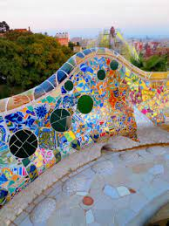  What is a Mosaic? | Theme: Mosaics  Artist Focus: Antonio Gaudi  Outcome: Design and produce a piece of Mosaic Art using polymer clay, shells and beans.  Link to History: Compare mosaics to Roman mosaics.
DT | 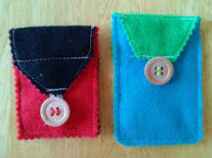  Can I create my own purse? | Textiles  Purpose: Design and make a purse for a particular purpose.  Focus:  Draw own pattern as a template to draw around and cut a range of fabrics.  Join fabrics using over sewing, backstitch and blanket stitch.  Confidently thread a needle using a smaller eye.  Add applique decorations using over sewing and running stitch.
Music | Mamma Mia (Charanga) Pop  Focus: learning about the language of music through singing and playing instruments.  Activities: singing, playing pitched and unpitched instruments, improvising and performing.
GREAT COMPOSERS -
Classical Period (1750 – 1820)
Focus: Listen and appraise the work of some well-known composers from the Classical Period (1750 – 1820)
PE  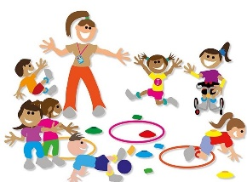 | Invasion Games  Gymnastics  Dance
Computing | How do we stay safe online?  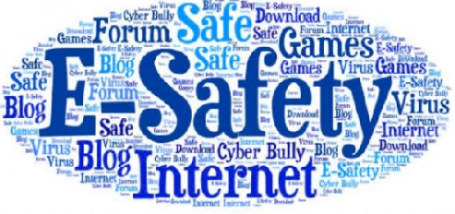 | E-Safety  Cyberbullying  Phishing  Reliable information
 | Can I create a podcast? | Audio editing  Digital recording  Recording sounds  Creating a podcast  Editing digital recordings  Combining recordings  Evaluating podcasts

RSHE | Relationships and sex education  Digital and media literacy  Physical health and wellbeing  Emotional health and wellbeing  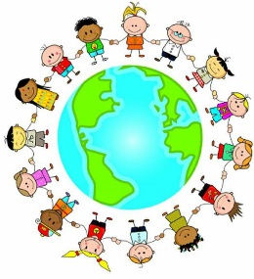 | Who chooses what I do with my body?  What do we mean by private and privacy?  Who can I talk to if I feel worried or if something feels wrong?  How do I keep safe when crossing the road?  Can I plan a safe walking journey?  How does it feel to try something new or difficult?  What have we achieved that we are most proud of?  How do we know if the choices we are making are healthy?  What does it mean to live a ‘balanced’ lifestyle?  What is cyberbullying?  What should you do if you witness cyberbullying?  What can you do if you are a victim of cyberbullying?
French | Module 1  JE ME PRÉSENTE  Module 2  EN FAMILLE  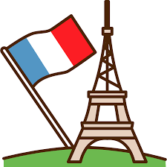 | Count to 20.  Ask somebody how they are feeling, their age, name and where they live.  Say how we are feeling, how old we are, what our name is and where we live.  Apply rules of adjectival agreement when saying our nationality.  Remember the nouns for family members in French from memory.  Describe our own or a fictitious family in French by name, age and relationship.  Count up to 100 in French.  Understand possessive adjectives better in French (‘my’ form only).

