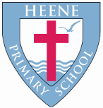
Heene Church of England (Aided) Primary School
‘Learning together, loving others, guided by God’

Year 6 Autumn 2022

TOPIC | Against All Odds
WOW STARTER | Blitz art morning

Subject | Key Question | Focus
Geography | Can a country be self-sufficient? | - What does self-sufficient mean?  - How does trade impact our lives?  - What is Globalisation?  - How climate impacts trade.
History | What was the impact of WWII and the Blitz on Britain and its people? | - How did the Blitz impact Britain? Where did it impact?  - Was Worthing impacted by the Blitz?  - What was the Battle of Britain?
Quality Texts as an English focus | Goodnight Mister Tom – Michelle Magorian  Malala, My Story – Malala Yousafazi  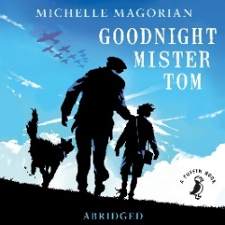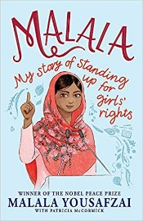
English Focus | All writing blocks will be 2 weeks.  Informal letter writing  Non-chronological report  War Poetry writing  Newspaper report  Narrative
Maths Focus | Number: Place Value (approx. 2 weeks)  Number: Addition, Subtraction, Multiplication and Division (approx. 5 weeks)  Number: Fractions (approx. 4 weeks)  Geometry: Position and Direction (approx. 1 week)
RE | Creation | Creation or Science? Conflicting or complimentary?
 | Incarnation | How is the son of man still on this Earth?
Science | What makes us different? | Evolution and Inheritance  - recognise that living things have changed over time and that fossils provide information about living things that inhabited the Earth millions of years ago  - recognise that living things produce offspring of the same kind, but normally offspring vary and are not identical to their parents  - identify how animals and plants are adapted to suit their environment in different ways and that adaptation may lead to evolution
Art | Can a Print be Made from Any Picture?  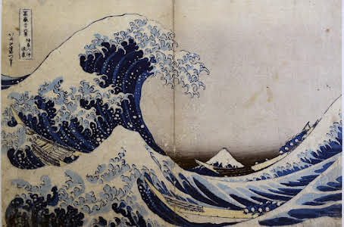 | Theme: Polyblock Printing  Artist Focus: Hokusai & Hiroshige  Outcome: Design and created my own interpretation of ‘The Great Wave’ and make a linocut print from it.  Link to History: Compare to recent prints
DT | How can I produce the best value and highest quality product? | Food  Purpose: Children will decide on the purpose of their product.  Focus:  - Become increasingly skilled at the techniques used when preparing mainly savoury dishes.  - Follow a recipe independently.  - Demonstrate an understanding of hygiene measures needed when preparing food.  - Cost their food products and consider this when making their product.
Music | Music Theory – notation and scores (7 weeks)  Glockenspiels (6 weeks)
PE | Invasion Games  Gymnastics
Computing | What is communication and how has it changed? | -How do computers communicate with each other?  -What are data packets?  -How do people collaborate online?  -How is reusing and modifying different to plagiarising?  -How has communication developed?
 | Is 3D modelling important to the world? | -What is 3D modelling?  -How can I manipulate 3D shapes?  -How do I make a 3D name badge?  -How can I use a placeholder to make a hole in a 3D shape?  -How can I make my own 3D building?
RSHE | What does it mean to be me? | - the importance of self-respect and how this links to their own happiness  - that in school and in wider society they can expect to be treated with respect by others, and that in turn they should show due respect to others, including those in positions of authority  - about different types of bullying, the impact of bullying, responsibilities of bystanders and how to get help.
French | A L’ÉCOLE | - Name the subjects we study in school in French with the correct definite  article/determiner.  - Extend sentences by giving an opinion on the various school subjects and extend even further by giving a justification for that subject.  - Start to tell the time by learning how to say time by the hour.  - Say at what time we study certain subjects at school.

