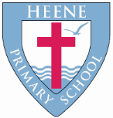
Heene Church of England (Aided) Primary School
‘Learning together, loving others, guided by God’

EYFS Autumn 2022

TOPIC | Marvellous Me
WOW STARTER | Classroom Treasure Hunt | Enrichment - Planned Trips or Visits | -Visit to St Matthew’s Church  -Autumn Walk  -Library Visit  -Dental Visitor  - Head Teacher Story Time

Subject | Key Question | Focus
Understanding the World-Geography | What is around my school? | Use photographs  Use maps  Local buildings and key features  Where is my home on a map?
Understanding the World-History | Who am I? | Ordering events  Classroom timetables  Use pictures  Use timelines  What does ‘past’, ‘present’ and ‘future’ mean?
Quality Texts as an English focus | 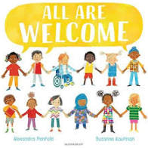  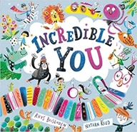  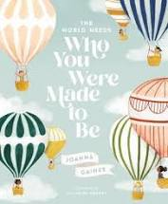  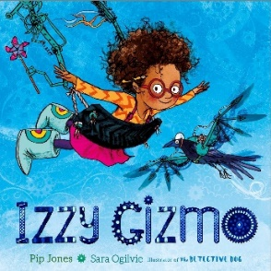  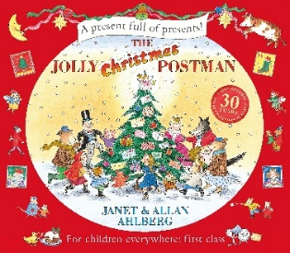  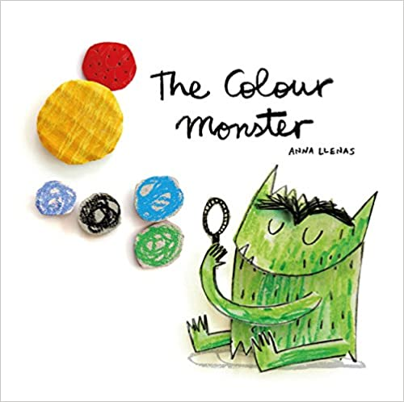
English Focus | All are welcome  Who you Were Made To Be  What I like and don’t like.  What makes me unique?  The Jolly Postman  Christmas cards  Letter writing  Incredible You  Self portraits  Name writing and age  Writing initial sounds  Family  Izzy Gizmo  What do you want to be when you grow up?  Different jobs in the world  Introduction to school  Understanding print  Name writing practise  Pencil grip  The Colour Monster  Talk about my feelings  What makes me happy, sad  Love, calm, angry
Maths Focus | Match and Sort  Comparing amounts, size and mass  Simple patterns  Representing 1,2&3  Comparing and composition of 1,2 & 3  Circles, triangles and spatial awareness  4 & 5  1 more and 1 less  Shapes with 4 sides, ordering events.  Zero, composition of 4 & 5.  Comparing mass and capacity.  Consolidation of 1-5.
Understanding the World-  RE | Where do I belong? | What the word ‘belonging’ means  Where they belong – family, CofE school, St Matthews Church  Emotional response to belonging  Ask questions about their place in the wider world  Religious celebrations – Diwali, Hanukkah.
Understanding the World-Science | Who am I? | Strand of Science: Body Parts  Focus: naming body parts, facial features and oral health.
 | What change is around me? | Strand of Science: Seasons  Focus: Change in matter – freezing and melting  Change in season - Autumn
 | Which material is best for a blanket? | Strand of Science: Exploring Materials (link to DT project)
Expressive Arts and Design-  Art | What can I create? | Theme: What can I create?  Outcomes:  Self portrait with pencils showing different types of lines  Paintings made using my fingers, hands and brushes  A model of something using junk materials
Expressive Arts and Design-  DT |  | Textiles  Purpose: To make a blanket for the Everywhere Bear.  Focus:  Join fabrics using glue, tape and treasury tags.  Develop fine motor control through funky finger activities.  Glue on decorations such as sequins.  Decorate with fabric pens.
Expressive Arts and Design-  Music | Learning and performing nursery rhymes and songs.  Charanga – Me!
Physical Development-  PE | Gaining independence:  Move in different ways  Listen and follow instructions  Use resources  Dress and undress  Spatial awareness  Play games
Understanding the World-Computing | What do people use computers for?  How can I use a computer safely? | Internet Safety:  Basic personal information – name, school, address  Username  Password
Personal, Social and Emotional Development-RSHE | How am I feeling?  How can I do the right thing? | Circle time  Role play scenarios  Visitors  The Colour Monster

