Dear Parents and Carers, 4th March 2022
Welcome to the first newsletter of the new half term. Thank you for your continued support for all we are trying to achieve here at Heene and we trust that last week offered you and your children a welcome breather from the routines of the school day and that you were able to spend some quality time together. We are sorry that the final day of the half term was overshadowed by Storm Eunice and school had to close. Thank you again for your support with this very difficult decision.
The past half term has been one where Covid-19 still dominated our thinking and planning but we are so grateful to the dedicated team of staff here at Heene for pulling together and doing all they could to ensure the children were happy, settled and continuing to learn.
This week the Newsletter is dedicated to celebration. We had hoped to celebrate the achievements of the children on the final day of the half term but sadly Storm Eunice prevented this. So this week we are trying to rectify that and today we are highlighting the children who have been awarded the title ‘Pupil of the Half Term’. The teachers have been asked to select one child for the half term, who truly demonstrated the Heene Way every day, showing kindness when kindness was not always easy, being Brave – even when faced with real challenges and striving to be the best they could be in all they did.
The teachers found this exceptionally hard because our school is filled with children who do amazing things every day and to be honest they could fill many pages with the children who made them smile with pride each day. Each week we give out Headteacher awards and from next half term we will be publishing these names in our weekly newsletter, so that you can celebrate with us too. Today we have set out the names of the children who have received the ‘Pupil of the Half Term Award’. The children received their award in assembly this morning. Well done to you all.
Our ‘Pupils of the Half Term’ were:
Early Years Cleo from Elmer and Christina from Gruffalo
Year 1 Edward from Funnybones and Cameron from Paddington
Year 2 Sybill from Jeffers and Archie from Gravett
Year 3 Emelia from Stanton and Timi from Pichon
Year 4 Monica from Rundell and Isla from Hardy
Year 5 Greta from Blackman and Zaydaan Mustafa from Morpurgo
Year 6 Will from Horowitz and Brooke from Almond

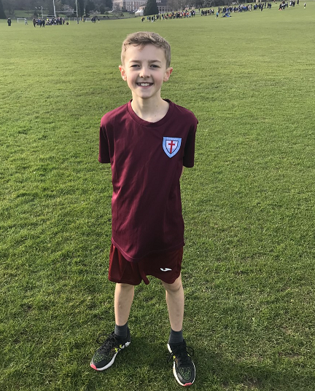

Congratulations also go to Lucas Dart who competed in the Southern Area Partnership Cross Country on Monday representing the Worthing Schools Sports Partnership. This event followed the cross country event at the Gallops in October where he placed 10th. He was up against the fastest cross country runners from the other Worthing schools, Lancing schools, Steyning schools, STARS schools, Shoreham schools & LASP schools. Lucas placed 36th out of 85 runners and we are extremely proud of him Well done!

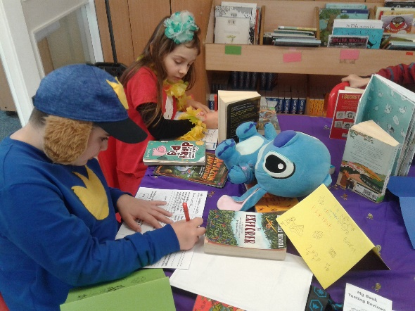
Thank you to everyone for the amazing turnout of costumes yesterday for world book day. The children had a day celebrating a range of rich and diverse children’s books and we were fortunate to have a visit from the poet Roger Stevens who entertained our older children with his hilarious poems!

The Friends of Heene Primary School are currently putting in place plans for a number of events that will take place before the end of the school year. Further details of these will follow shortly. The financial support we get from FoHPS is invaluable and we hope as many of you as possible will help to support these events whether this is by volunteering your time or just taking part in the events themselves.
Many of you will be aware that the playground play equipment was planned to be repaired during the half term holiday. Unfortunately we were let down by the contractors so we are still unable to use the equipment. This is incredibly frustrating and we are doing everything we can to resolve the situation.
Please remember to book your parents consultation appointment next week via eSchools (with the exception of Year 5 who have already had their Spring term consultations). If you have any difficulties with this please do contact the school office who will be happy to assist you.

We look forward to seeing many of you in school next week during the consultation evenings. We are there to talk to you about any questions you may have so please do come and talk to us.

Best wishes
Julia Sherlock and Joy Waelend
Co-Headteachers

