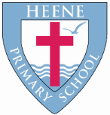
Heene Church of England (Aided) Primary School
‘Learning together, loving others, guided by God’

Heene Curriculum Autumn 2021

Year Group | Key Texts | Maths | RE | Science | History | Geography | Computing | Art | DT | PE | RSHE | Music | French
EYFS  Marvellous Me  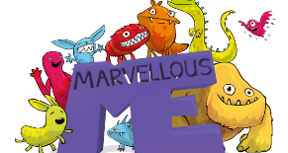 | -Super Duper You  -All Are Welcome  -Who you were made to be! | Getting to know you  It’s Me  Numbers 1,2,3  Light and dark numbers to 5 | Getting to know you  Belonging to  Heene Primary  St Matthews  Incarnation  Why do Christians perform Nativity Plays at Christmas? | Body Parts  Seasons  Change in matter – freezing and melting  Change in season – Autumn | Who am I? | Where are we? | E-Safety | Making My Mark  Drawing  Painting  Sculpture | Textiles  Make a class blanket to keep a nursery rhyme character warm. | Gaining Independence  Gymnastics | Looking after myself and others | Me!  (Charanga)
Year 1  The Great Outdoors  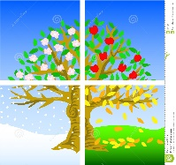 | -Tree  -The Squirrels Busy Year  -If All the World Were… | Place value (within 10)  Addition and subtraction (within 10)  Geometry: Shape  Place value (within 20) | God  What do Christians believe God is like?  Incarnation  Why does Christmas matter to Christians? | Seasonal Changes | Have I always lived this way? | Where is my school and where do I live? | E-Safety  Internet skills – Google image search, e-mails as a form of communication, SMART rules | Andy Goldsworthy and natural sculpture | Mechanics and structures  Design and make a card with a moving picture using levers and sliders. | Multiskills  Skipping  Ball skills  Dance | Discuss my feelings  Think about Safety online and offline | Hey You  (Charanga) Hip Hop and Rap  Nativity songs
Year 2  Here We Are  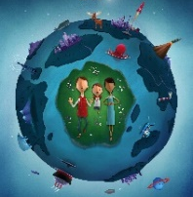 | -Here We Are  -Poles Apart  -An Atlas of Imaginary Places | Place value  Addition and subtraction  Measurement: money  Multiplication and division | Creation  Who made the world?  Incarnation  Why does Christmas matter to Christians? | Living  Organisms  Materials | Has the town where I lived changed? | What would you find on a West Sussex journey? | E-Safety  Internet skills – Bookmarks, digital footprint, communication, | Texture and Tone  Worthing beach in the style of George Seurat | Textiles  Design and make a Christmas decoration. | Multiskills  Ball skills  Gymnastics  Games Making | Ways to cope with my feelings  Know how to stay safe online and offline | Hands, Feet, Heart  (Charanga)  South African music  Christmas Songs | Early Start French  Greetings, goodbyes -  How are you?  What's your name?  Alphabet  My family  Happy Christmas!
Year 3  It’s a Mystery | -How to Live Forever  -The First Drawing  The Wild Girl | Place value  Addition and subtraction  Multiplication and division | Creation  What do Christians learn from the creation story?  Incarnation  What is the Trinity? | Forces - Magnets and springs | What was life like when our Ancient Ancestors were alive? | What makes the South East? | E-Safety  Blogging – diary on computers | Abstract Art | Cooking and nutrition  Baking biscuits for an audience. | Multiskills  Skipping/Fitness  Invasion Games  Gymnastics | Identify good and bad secrets  Be responsible for myself  Manage my feelings | Let your Spirit Fly  (Charanga R&B)  How did our Ancient Ancestors make music? | Niveau Bleu  Module 1  Greetings  Paris Landmarks  Module 2  Numbers 0-6  Countries of the UK
Year 4  All the World’s a stage  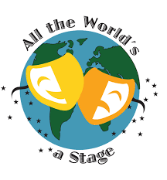 | -Because  -A Stage Full of Shakespeare  -A Gladiator Stole My Lunchbox | Place value  Addition and subtraction  Measurement: Length and perimeter  Multiplication and division | Creation  What do Adam and Eve’s actions teach us?  Incarnation  Do you believe God came to Earth at Christmas? | Living things and their habitats  Animals Inc. Humans | Were the Romans really rotten? | How does the UK work for us? | E-Safety  Blogging – diary on website | Mosaics  Antonio Gaudi | Textiles  Design and make a purse for a particular purpose | Invasion Games  Gymnastics | Body privacy  Accessing emergency help  Facing challenges | Mamma Mia  (Charanga) Pop  Great Composers  Classical Period (1750 – 1820) | Niveau Blanc  Module 1  Dans le jardin  Module 2  Les animaux  Couleurs
Year 5  All Change!  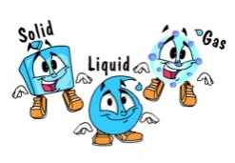 | -The Boy at the  -Back of the Class  Beowulf | Place value  Addition subtraction  Statistics  Multiplication and division  Measurement: Perimeter & area | Creation  How do Christians interpret the Creation story?  Incarnation  Does the world need a messiah? | Properties and changes of materials | What did the Vikings do for Britain? | Where on earth? | E-Safety  Podcast – record, import, software | Tapestry  Telling a story… | Textiles  Design and make a pencil case | Swimming  Invasion Games  Gymnastics  Dance | Loving relationships  Online safety and relationships | Pulse & Rhythm  Rhtymn boxes and composing patterns  Boomwhackers –pitch and pentatonic scales – compose and perform | Niveau Rouge  Module 1  Telling the time  Town buildings  Module 2  Town buildings cont.  Numbers 22-31  Telling the time
Year 6  Against all Odds  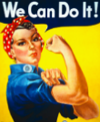 | -Goodnight Mr Tom  -Malala | Place value  Addition, subtraction, multiplication and division  Fractions  Geometry: Position and direction | Creation  Creation or Science?  Incarnation  How is the son of man still on this Earth? | Incarnation  How is the son of man still on this Earth? | Did World War 2 change Worthing? | Canada linked to World War Canadian Bomber. | E-Safety  Podcast – edit, combine, quality | Polyblock Printing  Hokusai & Hiroshige | Textiles  Design and make a food product  of their choice.  Market research. | Invasion Games  Gymnastics  Dance | Individuality and media influence  Gender roles  Online privacy | Music Theory – notation and scores  Glockenspiels | Niveau Tricolore  Module 1  Months  How are you?  Module 2  Nationality  In the classroom

