Dear Parents and Carers,
Welcome to the final week of this very hectic, busy and challenging term.
Nativity Performances in Covid times:
We are so looking forward to seeing parents in school next week to watch the wonderful Christmas celebrations which the younger children have prepared for you. Due to the continuation of our COVID concerns, we are limiting the numbers who are able to watch the shows to one ticket per child. We are so sorry that we are not able to do more than this, but we, once again, have to keep the safety of the Heene community at the centre of our planning and organisation. With tighter restrictions in place, we are having to keep a close eye on the guidance we have to follow but I do hope that those of you who are able to attend the performances, enjoy them as much as the children have enjoyed putting them together for you. For those of you attending a performance in the hall we would ask that you come wearing a mask as all staff will be once again be wearing masks in communal areas and whilst travelling through the school.
Church celebration next Friday: We are currently still planning to attend church next Friday as part of our end of term celebration. Unfortunately, due to the tighter restrictions which we are going to have to put in place, we are not going to be able to invite parents to join us for this service. We are really sorry about this, but would ask for your understanding in trying to keep the children and the school community as safe as possible leading up to the Christmas holidays.
Staff update: We have continued to be challenged this week by having enough teachers for all of the classes in the school and have managed again to reach the end of the week with all the children having a full week taught in school. We have heard this week of local schools where children are being taught in rotation, where the Headteacher, has taught all week and where some classes have been sent home or parts of the school closed because of the lack of teachers well enough to be in school. I am so grateful to our loyal bank of supply teachers who are prepared to teach wherever we ask them to teach and ensure the children remain safe in the classes and undertake learning planned for them by the teacher. We have only managed to do this because of the decision we took last week to pre book supply staff rather than wait until they might be needed. Most of the children have been amazing too and have responded positively to the change of teacher which has been necessary. We are hoping the two week Christmas break will give us the opportunity to re-group, get well and begin the New Year in a healthy place.
Mr Parsons: I am delighted to let you know that Mr Parsons is now feeling much better and is able to begin his return to us at Heene. I know the Morporgo children will be pleased to see him back in class and this will take place early in January.
Miss Atkinson: We are also pleased that Miss Atkinson will soon begin her return to us following a close family bereavement and we are delighted that she is now well enough to be able to do so.
Mrs MCGinley and Funnybones Class: I am delighted to be able to let parents of Funnybones class know that Mrs McGinley has agreed to continue as their class teacher, whilst we continue our search for the right teacher to take over from her in the new year. This is proving to be a difficult task but we will continue to look and continue to be grateful to Mrs McGinley for her willingness to remain in the classroom after Christmas.
Mrs Cannon: As we made you aware in last week’s newsletter, Mrs Cannon will be leaving us at the end of term. We will be very sorry to see her go, but are excited for her future career change. From January, Mrs Cannon’s class will be taught by Miss Carnegie whom we have been delighted to welcome to Heene. During this coming week, she will get to know the class a little in readiness for teaching Stanton class after the Christmas break. More details will follow during this coming week.
Recruitment of a new Headteacher for Heene:
We have begun to look for a new Headteacher for Heene, who will take over from Mrs Sherlock and myself in September 2022. We have begun to take interested leaders round the school and to show them the potential which Heene has. We are excited to let you know how this search continues as we enter January.

Here is a newsletter note from Mrs Daisley our SENCO:
Many thanks for your patience while I have settled into my role at Heene. It has been wonderful getting to know the children and staff.
I am now looking to book in spring term meetings with parents of children who are recorded on our SEND Register. To speed up the process, the office team have kindly agreed to contact you on my behalf to book these meetings. With increasing COVID restrictions and the new variant in mind, as well as the knowledge that there was a significant spike in cases after Christmas last year, I am booking these meetings as telephone meetings. I appreciate this may be frustrating, but as soon as we can safely have multiple visitors into school, we will do so.
Please note, these meeting slots are for parents whose children are recorded on the SEND Register who I have not met already this term. If your child has an EHCP, or we have already met this term, I will contact you after the Christmas break to arrange a meeting later in the spring term.
If we have not already met and you are not contacted by the office team by the end of Wednesday 15th December, but you think your child is recorded on the SEND Register, please email the office who will pass on the message to me and I will contact you.

And so to our learning for the week ahead

Reception Classes
In Gruffalo and Elmer classes the children will continue the topic ‘Marvellous Me’. In English, they will be reading lots of Christmas cards. We will be learning about how to write our own Christmas cards, including starting with ‘To’ and signing our name at the bottom. In Gruffalo Class we still have a Christmas Post Office role play for the children to send their cards and parcels to their friends.
In phonics the children will be learning the letters – v, y, w, z, x. They will be learning to build, read and spell simple cvc words that contain the letters taught so far. Keep a look out for their Phonics Home Learning book which will come home on Thursday (Elmer) and Friday (Gruffalo) for them to practise these letters. Please make sure this book comes back to school every Monday so we can stick the next set of letters in.
In Math’s we will be consolidating our learning this term on numbers 1-5. Each day we will focus on 1 number. They will be learning how to write each number, be recapping 1 more and 1 less than the number and the composition of each number.
In Geography we will be looking at where our school is in Worthing and trying to find it on the map. The children will look at some surrounding landmarks that might be able to help us find our way from home to school. We will also most likely be talking about Father Christmas’ journey to our homes on Christmas Eve and thinking about the map he might use.
Year 1
In English we will publish our poem about our special person.
In phonics we continue to revise sounds we have learnt before but with a focus on handwriting. We will also practise using the sounds to write words and sentences.
In Maths we will be playing math’s games to help reinforce what we have been learning.
In RE we will be learning about the first visitors to see baby Jesus – the shepherds.
In RSHE we will continue learning about the people who keep us safe and what they do.
In Science we will be thinking about what happens to trees in winter and will make a picture.
In Design and Technology we will make our Christmas card with a moving part.
In Geography the children will be learning about a compass and will go outside in the playground and use one.
Please can you continue to help your child learn their lines for the Nativity play if they have any. They were sent home last week. Many thanks.

Year 2
We are very excited about going on our History trip to Worthing Museum on Monday 13th December, in the morning. It will be so beneficial for the children to see and hear about the historical changes that have taken place as Worthing has grown from being a village to a town and how trains affected that change.
We are also thrilled to share our performances of ‘It’s a Party’ with you! Rehearsals are going well, your children have worked so hard as a team and thank you for supporting us with costumes and the learning of lines and songwords.
In between times we will be completing our Design and Technology task of making a 3D Christmas tree decoration and making Christmas cards. We will also be solving Christmas number problems and reading Christmas books.

Year 3
Christmas: We have a few plans (which we are keeping a secret!)
Maths: We will be learning the 8 times table by linking it to our learning of the 4 times table last week. We learn how to multiply by 8, divide by 8 and use our knowledge of the 8 times table to solve problems.
English: We will be publishing our non-chronological reports about the Stone Age. We were hoping to share it with Year 2, but we may have to do that next year.
RE: We will be creating a piece of art to represent the Holy Trinity.
Art: We will be evaluating our pieces of abstract art.

Year 4
As we edge closer to the Christmas holidays, the Year 4 team would like to congratulate the children on a successful term.
Next week, we look forward to lots of festive events, including watching the KS1 nativity and leading the church service at St Matthews.
In English, we will be finishing our reports on Boudicca’s rebellion against the Romans. We will be publishing our learning and presenting it to a Year 3 audience.
In Maths, we will be solving reason and problem solves questions with a festive feel.
In science, we will be learning to understand the different parts of the digestive system. Children will be researching different parts, working towards making an informative booklet on the topic.
In RE, children will be learning about Christmas. We will be focusing on the nativity story, Christingleand advent.
In PE, will concluding our unit of learning on ball skills in football and line dancing in movement.
In Geography, we will be using four figure grid references on a map to locate different cities in UK.
In computing, we will be concluding our unit of learning on ‘how to blog safely’. The children will be given the opportunity to review the effectiveness of each other’s blogs.
In addition to all of the above, the children will have time to get festive and creative – we will be making Christmas decorations out of reusable materials.

Year 5
English: We will be writing our Christmas stories building on the work we have already done this week.
Maths: We will be finishing off our work on area and then consolidating the learning over this half term.
Science: We will be drawing a conclusion to our work on forces and looking at the effect of friction.
Art/History: We will be finalising our individual pieces of the Bayeux tapestry and then joining our pieces together to make one long tapestry.
R.E: We will be concluding our work surrounding the question "Was Jesus the Messiah" and looking at the question "Has Jesus been forgotten in amongst the tinsel?"
Alongside all of this, we hope to find time for some Christmassy activities to finish off this half term.

Year 6
Over the next week we will be looking forward to Christmas!

English: we will conclude writing our stories and reading the end of Goodnight Mister Tom and Malala’s story. We may also have some Christmas themed activities about Christmas around the World.

Maths: focusing on coordinate grids and finding Christmas themed objects – as well as some Christmas themed maths code breakers, jokes and fraction problems!

RE: we will conclude our learning about Jesus as the Messiah and continue to prepare for Christmas through Advent.

Geography: We finish our leaflets detailing whether we would rather live in West Sussex or an area of Canada.

History: We will be presenting what we have found out through our own research on WW2.

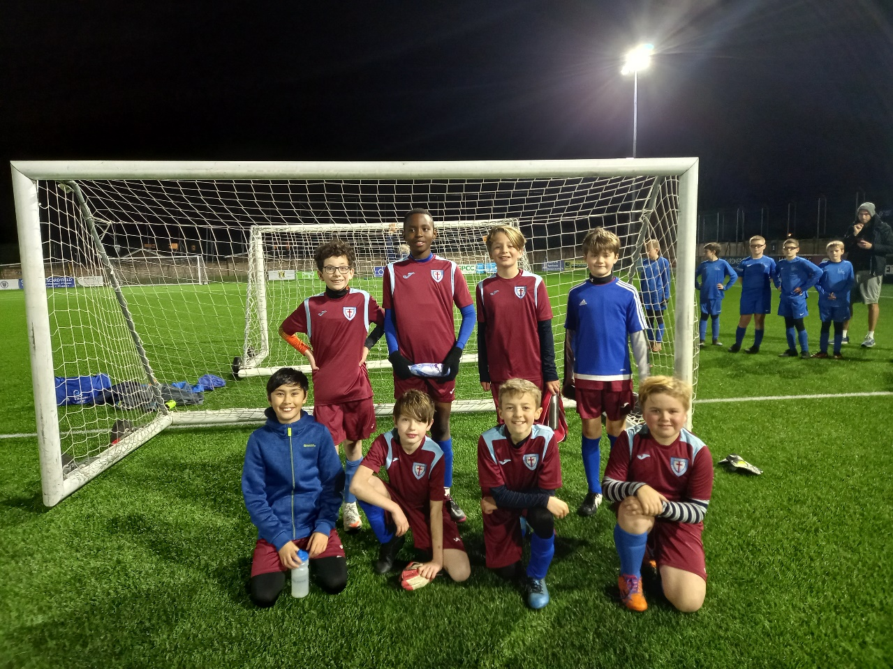
On Tuesday 30th November I accompanied the Y6 footballers to a tournament at Sussex FA in Lancing. Considering it was the boys first outing as a team together they listened well and drew 2 out of their 6 games. Thank you to all who participated and to the parents who came along to support the event on a windy, cold November night. Miss Moyle

Thank you for your continued support –

Joy Waelend
Interim Co-Headteacher

